Stop Scrolling! (Season 1, Episode 2)


Scrolling through Quora to answer some questions while having one of Nicolas Cole YouTube videos playing in the back ground.
(Yes, I was multitasking. Don’t give me that look — we all do it)

Anyway, I found something that forced me to STOP (no, it wasn’t some tiktok stunt):
Before I reveal this to you, let me just say I hate ads but when an ad stops my brain — I need to know why!!!!
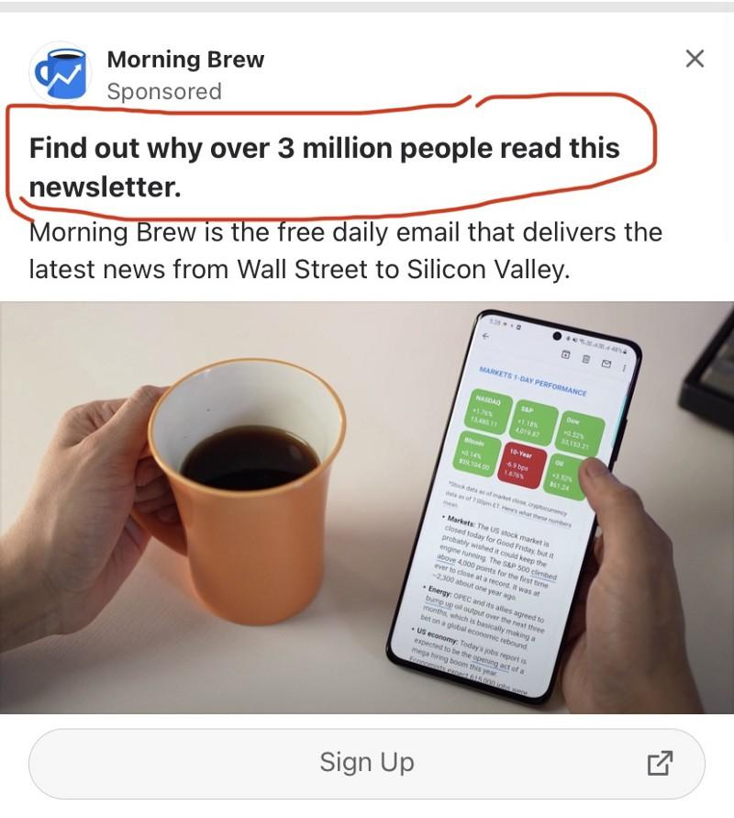
Morning Brew Engineering How dare you do this to me?

The hook held me by my throat-grasping for air.
3 million people? Damn it! I’m late to the party! Why didn’t I get an invite earlier? Could my friends be on this list & never mentioned it to me🤔?
All these thoughts ran through my head.
Holding my throat wasn’t enough — they went further to shut my mouth with the “latest news from Wall Street to Silicon Valley”

My eyes popped out at this point. I paused the YouTube video playing in the background and thought to myself:
“Wait! You mean you’ll give me gist from Apple, Facebook, Google?”
“As in gist on how an Intern sent out an empty email and got the whole department’s salary slashed by half?”
“Count me in!!”
It’s no brainer I clicked on the “Sign up”
I mean, Wouldn’t you have done same?
Long story short — I signed up (this part got even more juicer. I’ll share later if you want me to?).

Then it hit me: Why don’t I help people feel the exact way I felt in those moments?
And this thread was born!
If you read to this point, here’s a token of appreciation:
Here’s the YouTube video playing in the background
Off to go continue watching. 🏃🏽‍♂️
And Morning Brew Engineering thanks for stopping my scroll. 👍🏾
If you enjoyed this — give it a 👏🏾👏🏾 so others can find it.

